

Requirement & Design Specification
Multi-store Sales Management System
Version: 1.0

– Hanoi, August 2022 –

Record of Changes
Version | Date | A*  M, D | In charge | Change Description
V1.0 | 20/5/2026 | A | ChiHTH | Context Diagram
V1.0 | 20/5/2026 | A | ChiHTH | Screen Descriptions
V1.0 | 20/5/2006 | A | ThangLV | Screen Authorization
V1.0 | 18/06/2026 | A | HoangND | Filter Product
V1.0 | 18/06/2026 | A | HoangND | Search Product
*A - Added M - Modified D - Deleted

Contents
Record of Changes 2
I. Overview 4
1. User Requirements 4
1.1 Actors 4
1.2 Use Cases 4
a. Diagram(s) 5
b. Descriptions 5
2. Overall Functionalities 5
2.1 Screens Flow 5
2.2 Screen Descriptions 5
2.3 SCREEN AUTHORIZATION 5
System Roles 5
AUTHORIZATION MATRIX 6
1. USER MANAGEMENT 6
2. PRODUCT MANAGEMENT 6
3. SALES MANAGEMENT 7
4. INVENTORY/WAREHOUSE MANAGEMENT 8
5. PURCHASE/SUPPLIER MANAGEMENT 9
6. CUSTOMER MANAGEMENT 10
7. FINANCE MANAGEMENT 11
8. REPORTS 12
8.1 Sales Reports 12
8.2 Inventory Reports 13
8.3 Customer Reports 14
8.4 Financial Reports 14
8.5 Product Reports 15
9. WEBSITE MANAGEMENT 15
2.4 Non-UI Functions 16
3. System High Level Design 24
3.1 Database Design 24
a. Database Schema 24
b. Table Descriptions 24
3.2 Code Packages 24
II. Requirement Specifications 25
1. <<Feature Name>> 25
1.1 <<UseCaseCode_UC Name>> 25
a. Functionalities 25
b. Business Rules 27
2. Common Functions 27
2.1 UC-2_Login System 27
a. Functional Description 27
b. Business Rules 29
3. Patron Feature 29
3.1 UC-5_Order a Meal 29
a. Functional Description 29
b. Business Rules 31
3.2 UC-6_Register for Payroll Deduction 31
a. Functional Description 31
b. Business Rules 32
III. Design Specifications 32
1. <<Feature Name>> 32
1.1 <<SubFeature Name>> 32
a. <<Screen/Function Name>> 32
UI Design 32
Database Access 32
1.2 System Access 33
a. User Login 33
UI Design 33
Database Access 33
b. Setting List 34
UI Design 34
Database Access 34
c. Setting Details 35
UI Design 35
Database Access 35
IV. Appendix 35
1. Assumptions & Dependencies 35
2. Limitations & Exclusions 36
3. Business Rules 36
4. .. 37

I. Overview

1. User Requirements

1.0 Context Diagram
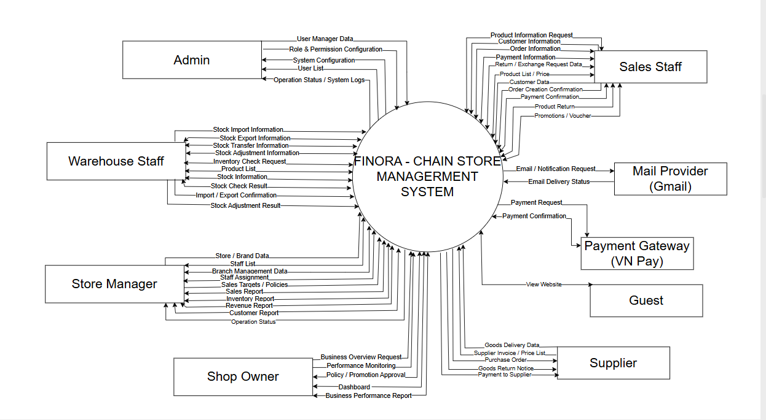

1.1 Actors
# | Actor | Description
1 | Admin | The person with the highest authority in the system is responsible for managing the entire configuration, access control, and technical operation of the system.
2 | Shop Owner | The chain store owner has the right to view all business data and make strategic decisions.
3 | Store Manager | The manager directly oversees a specific point of sale within the chain. They are responsible for the day-to-day operation of that store.
4 | Sales Staff | The staff directly handle sales transactions at the counter.
5 | Warehouse Staff | The employee is responsible for receiving goods, shipping goods, and managing inventory.
6 | Guest | External users can access the company's website. No login is required.

1.2 Use Cases

a. Diagram(s)
[Provide the UC diagram(s) to show the actor-UCs and UC-UC relationships like the sample below. You can have multiple UC diagrams for the system]

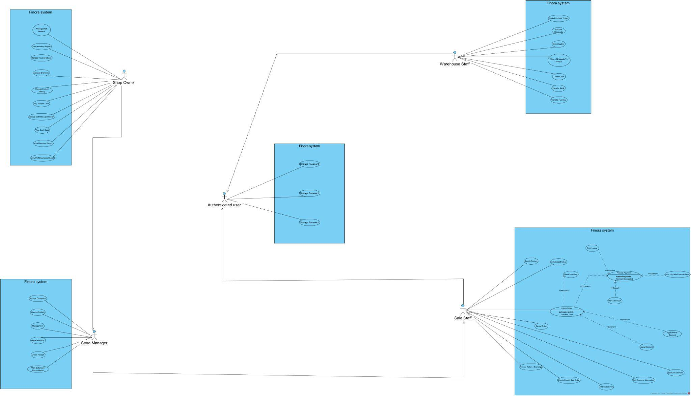

Use Case Diagram1.jpg

b. Descriptions

ID | Feature | Use Case | Use Case Description
UC-1.1 | Authentication | Login | User logs into the management system using username and password
UC-1.2 | Authentication | Logout | User logs out and ends the working session
UC-1.3 | Authentication | Register | New users create an account by entering required personal information and login credentials. The system validates the input data, checks for duplicate username/email, creates the account, and redirects the user to the login page or dashboard after successful registration.
UC-1.4 | User Management | Manage Staff Accounts | Create, update, lock staff accounts and assign roles
UC-1.5 | Authorization | Manage Roles & Permissions | Create roles and assign permissions to system modules
UC-1.6 | Branch Management | Manage Branches | Add, update or close store branches
UC-1.7 | System Configuration | Configure System | Configure VAT, currency, company information and invoice templates
UC-1.8 | Audit Log | View Activity Logs | Monitor user activity and system logs
UC-2.1 | Audit Log | View System Logs | View system operation history
UC-2.2 | Product Management | Manage Categories | Create, edit and delete product categories
UC-2.3 | Product Management | Manage Products | Manage product information
UC-2.4 | Product Management | Manage Product Pricing | Configure selling prices for each branch
UC-2.5 | Product Management | Search Products | Search products and view stock quantity
UC-3.1 | Product Management | Manage Units | Manage product unit conversions
UC-3.2 | Sales Management | Create Sales Order | Create POS sales orders
UC-3.3 | Sales Management | Apply Discount | Apply discounts to sales orders
UC-3.4 | Payment | Cash Payment | Process cash payments
UC-3.5 | Sales Management | Print Invoice | Print or reprint invoices
UC-3.6 | Sales Management | Process Return/Exchange | Handle product returns and exchanges
UC-3.7 | Sales Management | Cancel Orders | Cancel orders and record cancellation reasons
UC-3.8 | Sales Management | Create Credit Sales Order | Create debt orders for VIP customers
UC-3.9 | Debt Management | Collect Customer Debt | Record customer debt payments
UC-3.10 | Sales Management | View Sales History | View completed sales orders
UC-4.1 | Supplier Management | Manage Suppliers | Manage supplier information
UC-4.2 | Purchase Management | Create Purchase Orders | Create purchase orders from suppliers
UC-4.3 | Purchase Management | Receive Goods | Receive goods and update inventory
UC-4.4 | Purchase Management | Return Goods to Supplier | Return damaged or expired products to suppliers
UC-4.5 | Supplier Management | Pay Supplier Debt | Approve and pay supplier debts
UC-4.6 | Purchase Management | View Purchase History | View inventory import history
UC-5.1 | Inventory Management | Stock Checking | Perform inventory stock checking
UC-5.2 | Inventory Management | Adjust Inventory | Adjust inventory after stock checking
UC-5.3 | Inventory Management | Transfer Inventory | Transfer products between warehouses or branches
UC-5.4 | Inventory Management | View Inventory | View stock quantity by product or warehouse
UC-5.5 | Inventory Management | Low Stock Alert | Receive notifications for low stock products
UC-6.1 | Customer Management | Add Customer | Create new customer information
UC-6.2 | Customer Management | Edit Customer Information | Update customer information
UC-6.3 | Customer Management | Search Customers | Search customer information
UC-6.4 | Customer Management | Manage Customer Levels | Manage Silver, Gold and VIP customer levels
UC-6.6 | Loyalty Program | Apply Loyalty Discount | Apply automatic discounts based on membership level
UC-6.7 | Debt Management | View Customer Debt | Monitor customer debt information
UC-7.1 | Finance Management | Create Income Receipt | Record income transactions
UC-7.2 | Finance Management | Create Expense Receipt | Record expense transactions
UC-7.3 | Finance Management | Manage Income & Expense Types | Manage income and expense categories
UC-7.4 | Finance Management | Daily Cash Reconciliation | Compare actual cash with system records
UC-7.5 | Finance Management | View Cash Book | Monitor cash flow and financial transactions
UC-8.1 | Reporting | View Revenue Reports by Time | View revenue reports by day, month or year
UC-8.2 | Reporting | View Revenue Reports by Branch | Compare revenue between branches
UC-8.3 | Reporting | View Employee Sales Reports | Monitor employee KPI and performance
UC-8.4 | Reporting | View Inventory Reports | Monitor inventory reports across stores
UC-8.5 | Reporting | View Profit & Loss Reports | Analyze revenue, expenses and profits
UC-8.6 | Reporting | View Debt Reports | Monitor customer and supplier debts
UC-8.7 | Reporting | View Loyalty Customer Reports | Analyze loyal and VIP customers
UC-8.8 | Reporting | View Best-selling Product Reports | Analyze best-selling and slow-selling products
UC-9.1 | Website | View Homepage | View banners and featured products
UC-9.2 | Website | View Company Information | View company information and introduction
UC-9.3 | Website | Send Contact Form | Send contact information to the company
UC-9.4 | Website Management | Manage Website Content | Manage banners, articles and website content

2. Overall Functionalities

2.1 Screens Flow

2.1.1 Overall Screen Flow

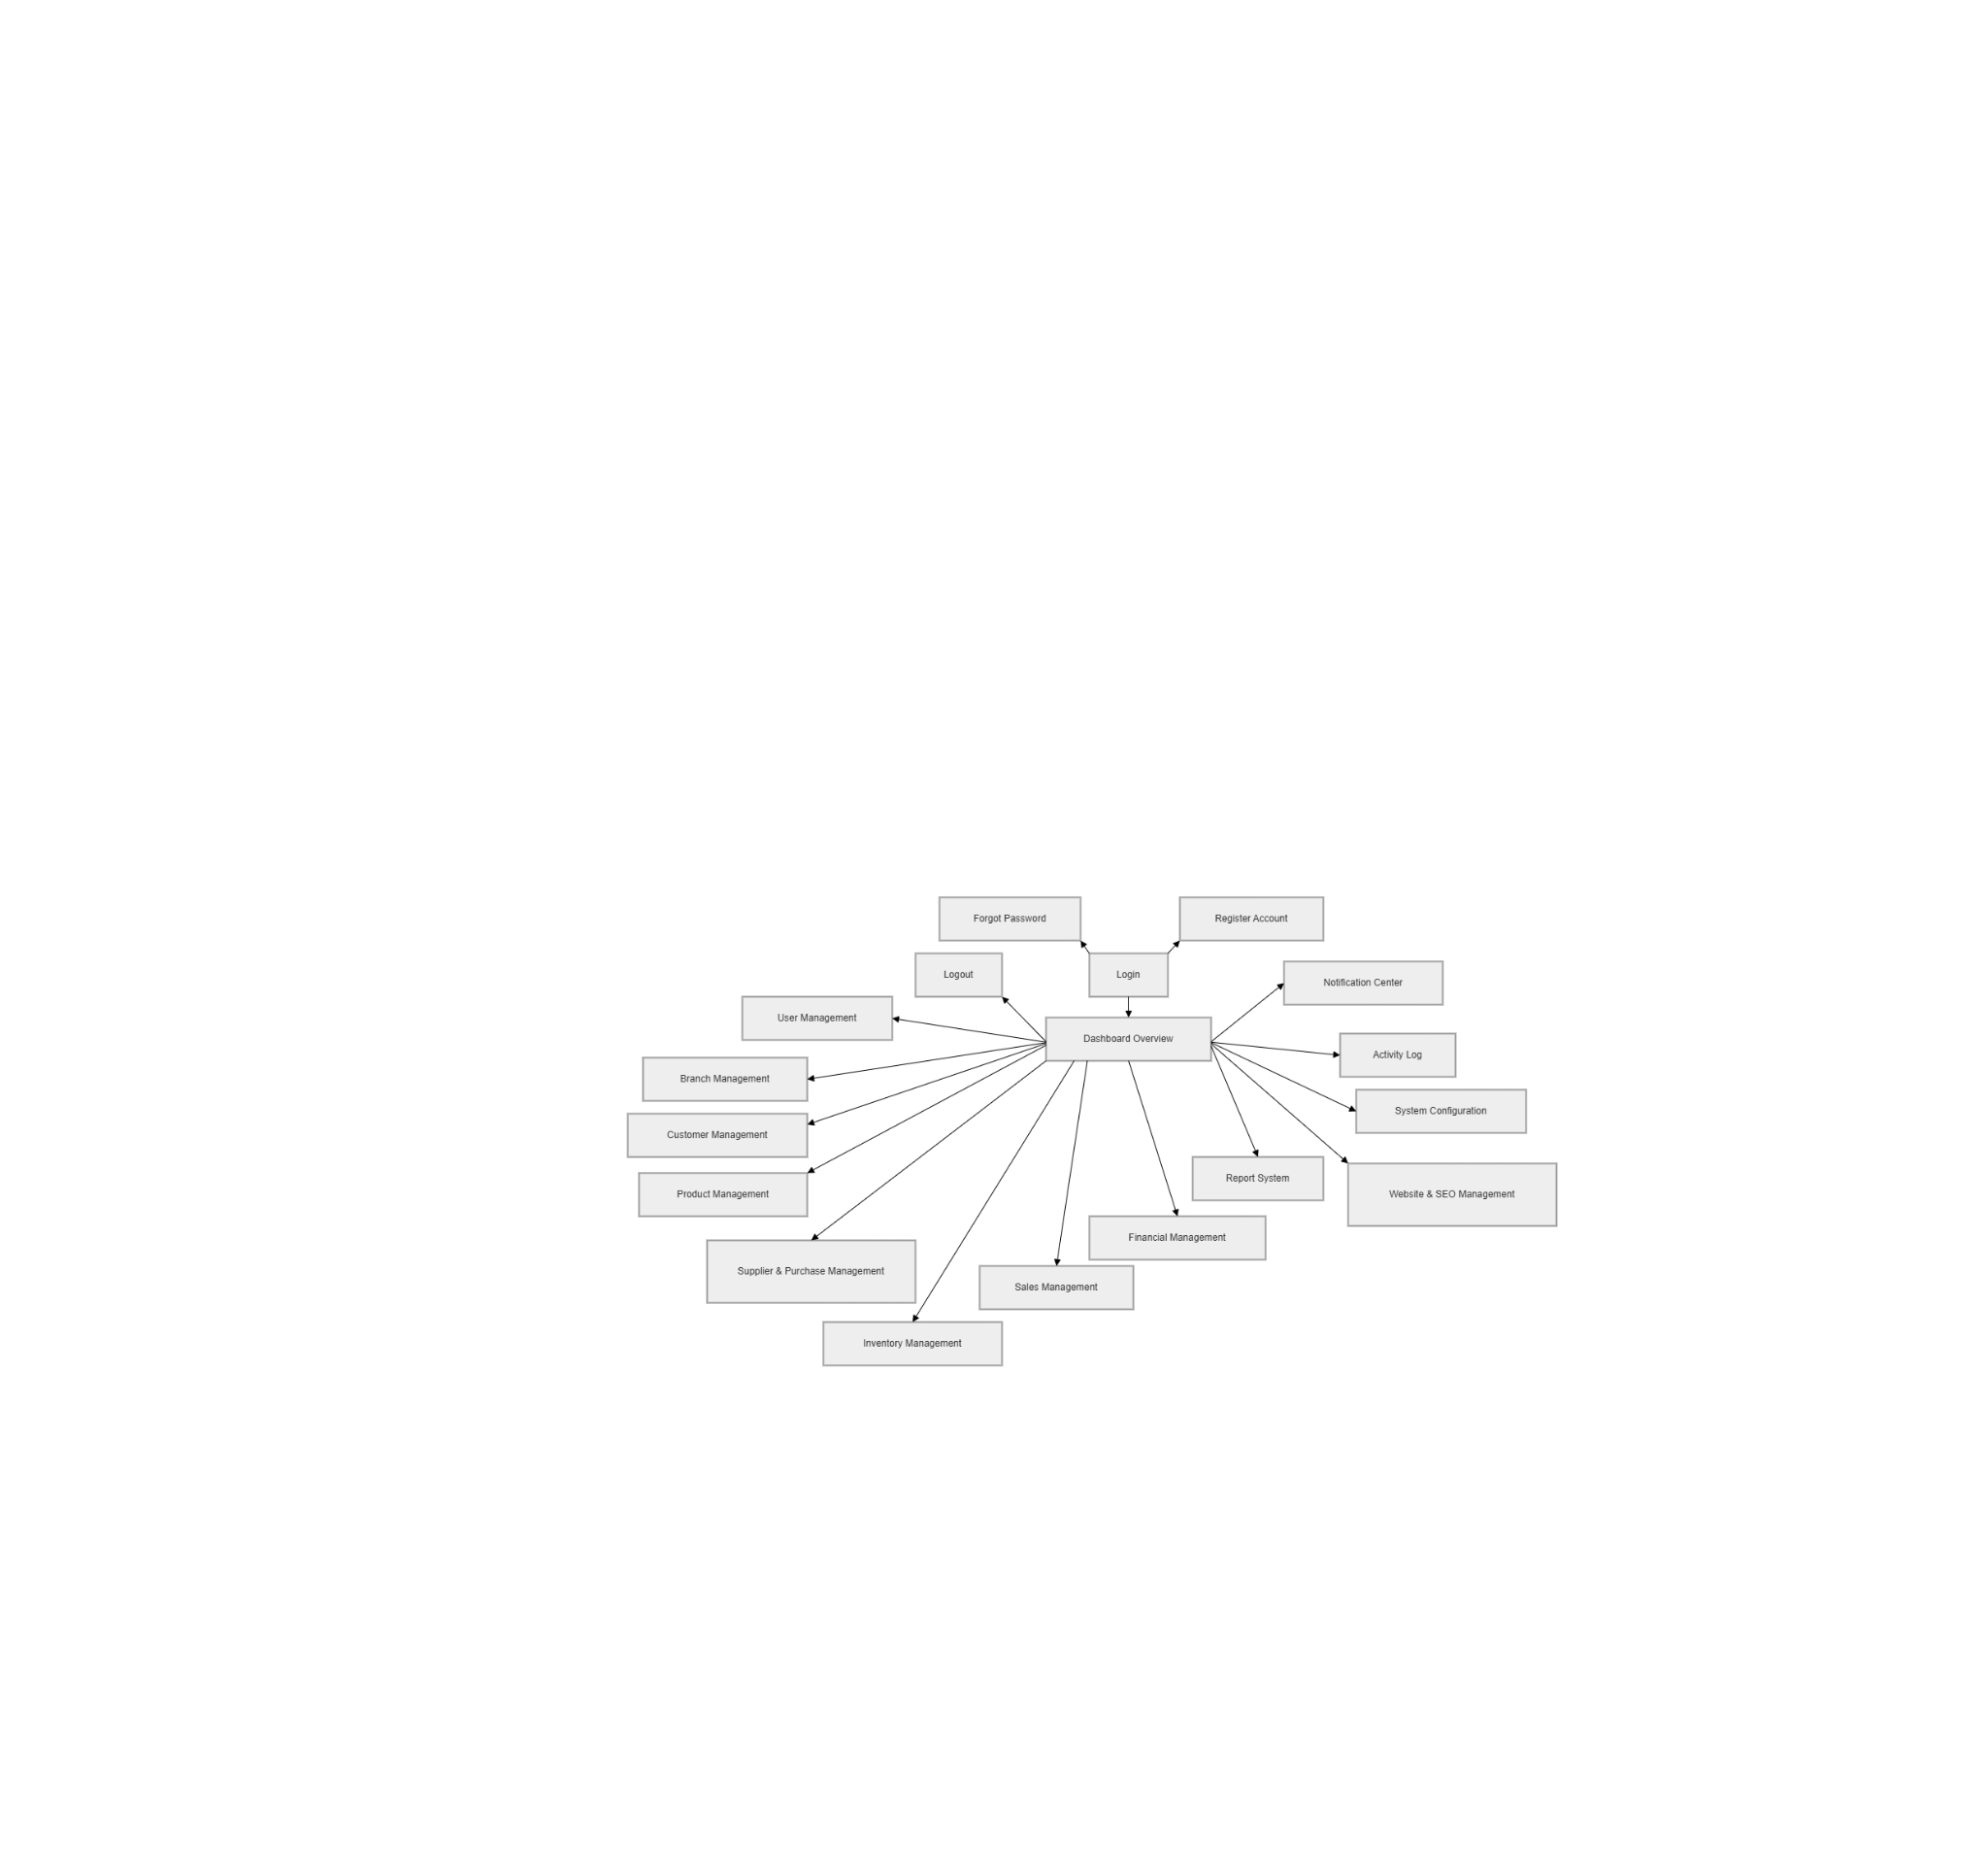

2.1.2 Authentication Flow
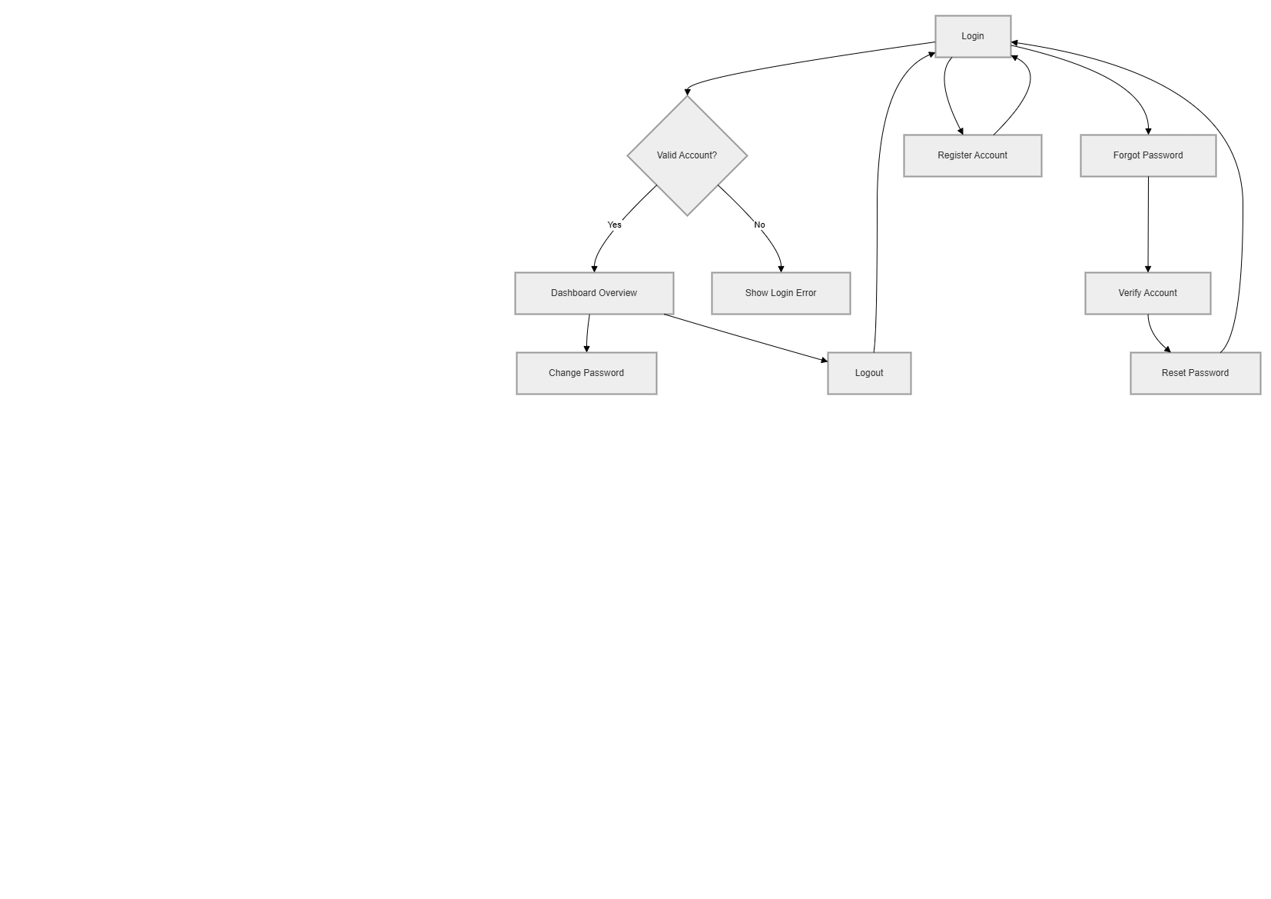

2.1.3 User and Authorization Flow

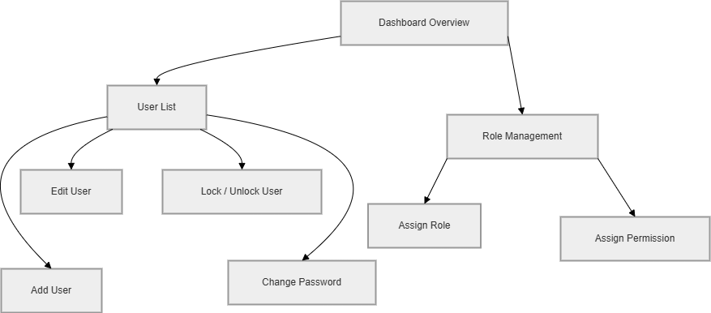

2.1.4 Branch Management Flow
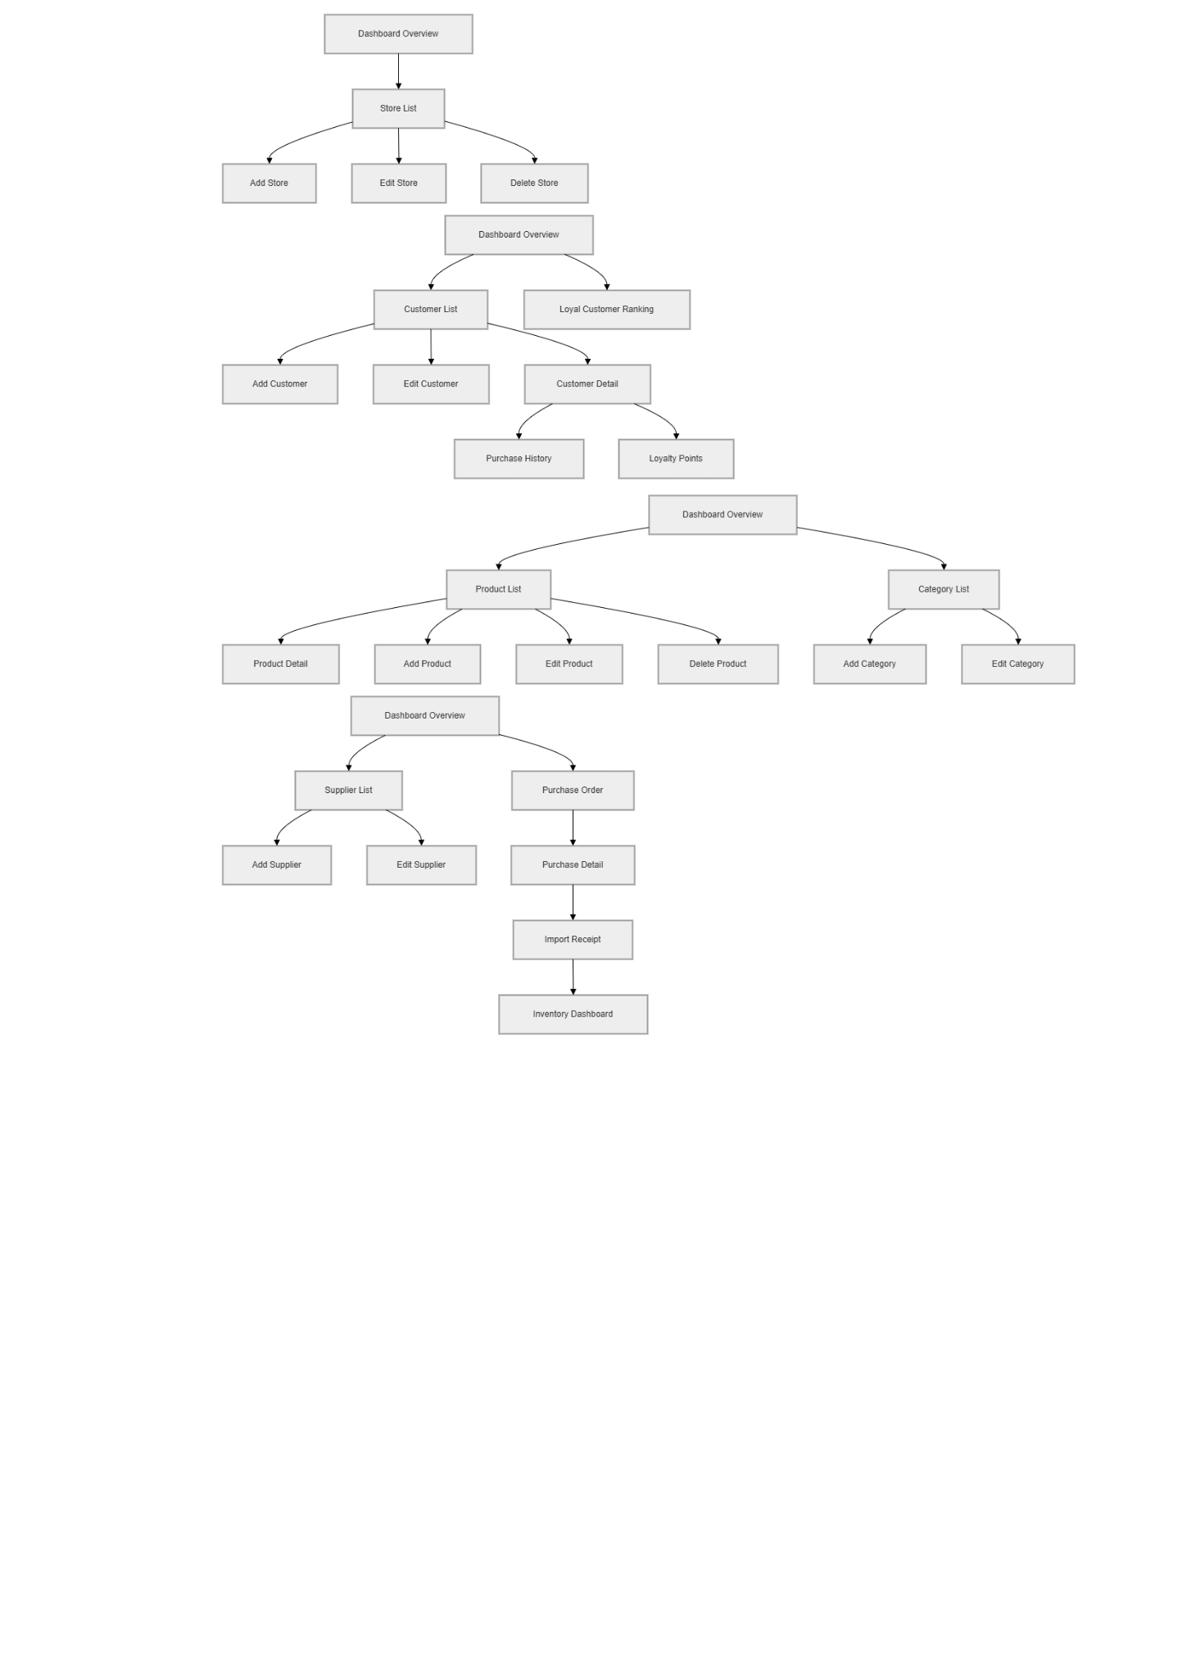

2.1.5 Customer Management Flow


2.1.6 Product and Category Management Flow


2.1.7 Supplier and Purchase Management Flow


2.1.8 Inventory Management Flow
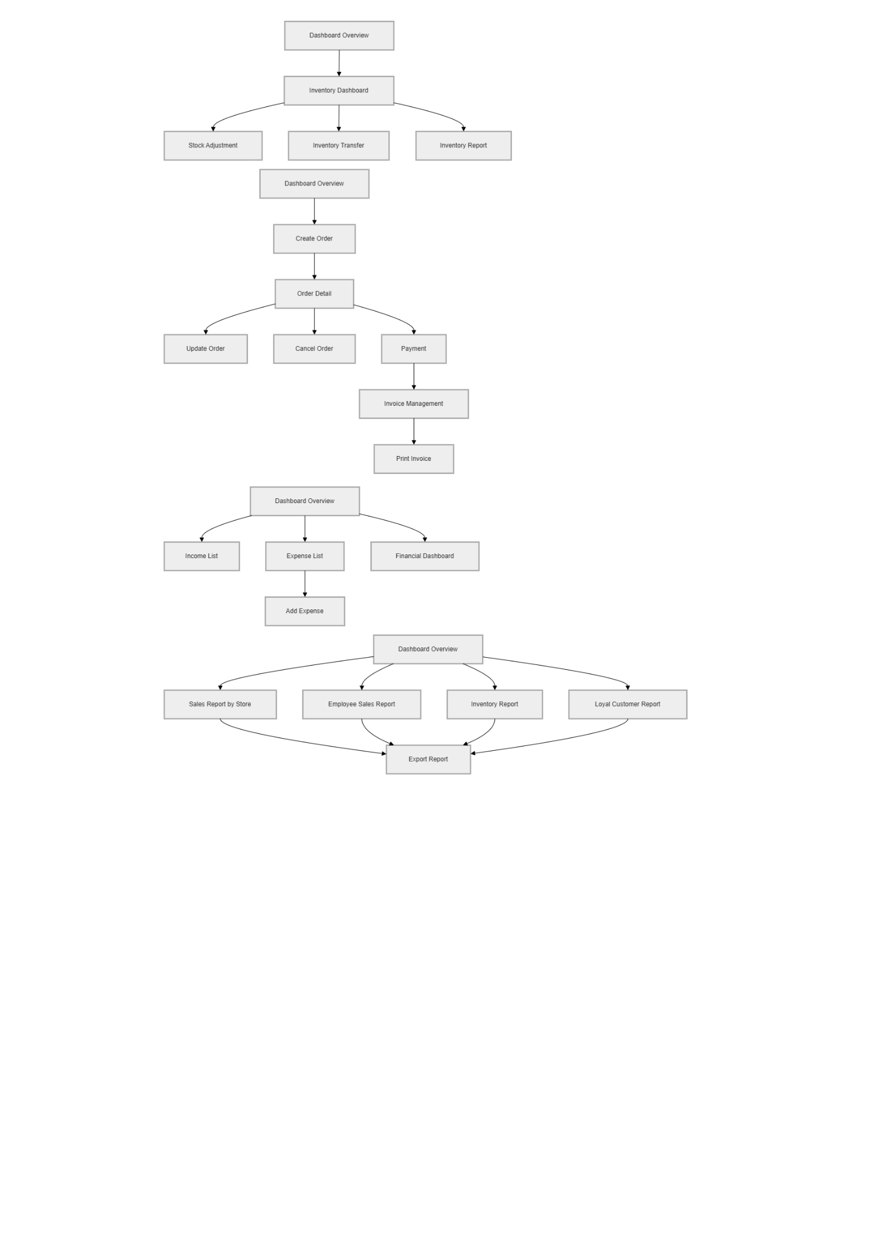

2.1.9 Sales Management Flow
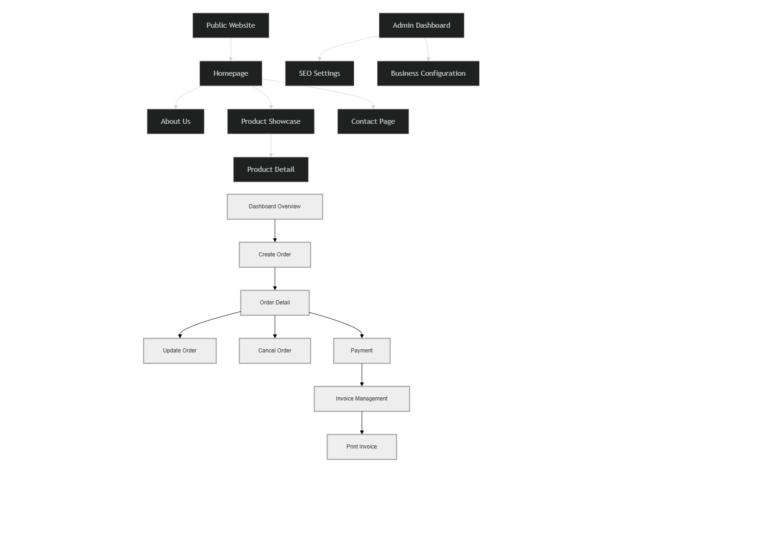

2.1.10 Financial Management Flow


2.1.11 Report System Flow


2.1.12 Website and SEO Management Flow
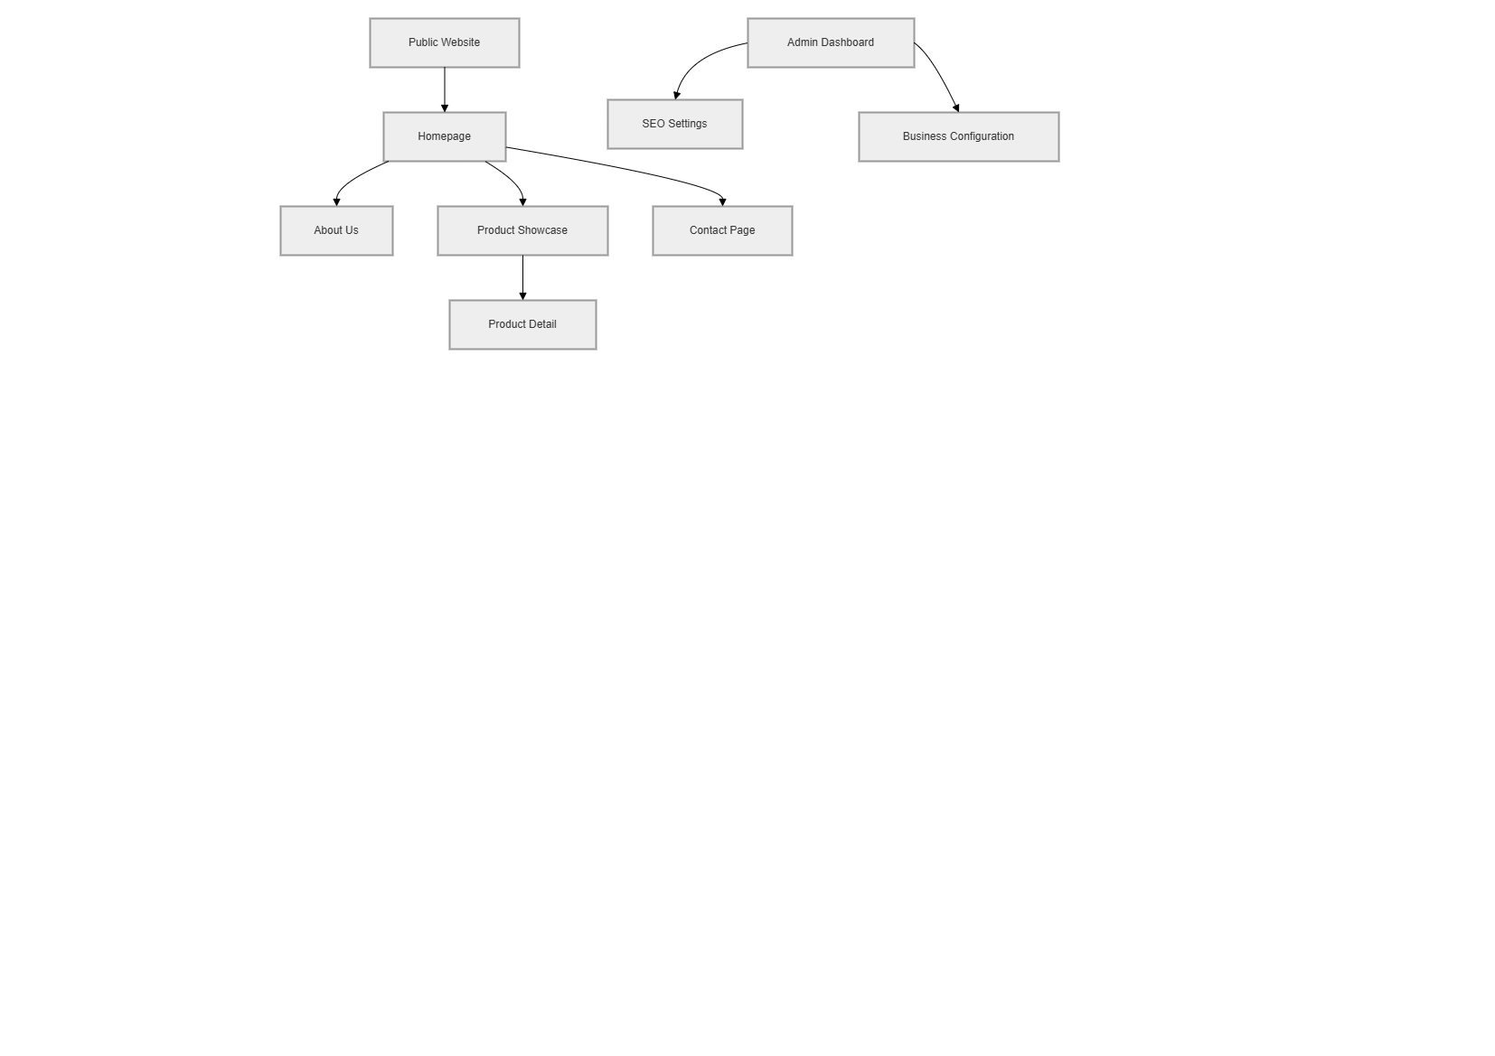

2.2 Screen Descriptions

# | Feature | Screen | Description
1 | Authentication | Login | Users enter username and password to access the system. The system identifies the user's role and assigned store branch (store_id) upon successful login.
2 | Authentication | Forgot Password | Users recover account access via an email verification process that sends a self-generated temporary password
3 | Authentication | Logout | Users securely end their working session. The system records the logout time in the activity log
4 | User Manager | User Manager | Admin views and manages all staff accounts across the entire chain or specific branches
5 | User Manager | Add/Edit User | Admin creates or updates staff accounts, assigning them to a specific branch and gán a single role per account
6 | User Manager | Search User | Allows Owner/Manager to search and filter users by name, email, phone, role, status, or branch.
7 | User Manager | Filter User | The system displays matching results to help manage user accounts efficiently.
8 | User Manager | Lock / Unlock User | Admin disables or enables account access. Locked users are prohibited from logging into the system
9 | User Manager | Redeem consumption points | Sales staff check points and redeem them for customers.
10 | User Manager | Change Password | Users change the password for their newly assigned account for security reasons.
11 | Authorization | Role Management | Admin defines system roles and assigns granular permissions for each module following the RBAC model.
12 | Branch Manager | Store List | Owner views the list of all active branches/stores within the Finora chain
13 | Branch Manager | Add Store | Owner manages branch-specific information including address, contact details, and assigned manager.
14 | Branch Manager | Edit Store | Owner updates branch information such as address and manager.
15 | Branch Manager | Seach Store | Allows Owner to search and filter store by name, email, phone, status, or branch.
16 | Branch Manager | Filter Store | The system displays matching results to help manage store efficiently.
17 | Customer Manager | Customer Manager | Sales staff browse customer transaction history and accumulated spending.
18 | Customer Manager | Add/Edit Customer | Staff registers new customers to track identity for the Loyalty program (point accumulation)
19 | Customer Manager | Search Customer | Allows Sales Staff or Store Manager to search and filter customer by name, email, phone, status.
20 | Customer Manager | Filter Customer | The system displays matching results to help manage customer efficiently.
21 | Customer Manager | Customer Detail | Staff views detailed customer profile and loyalty points.
22 | Product Manager | Product Manager | Users browse all products. Includes quick search by name or barcode and displays real-time stock levels for the current branch.
23 | Product Manager | Product Detail | Users view detailed product information including price and stock quantity.
24 | Product Manager | Add/Edit Product | Store Managers manage product data, including categories and unit conversions
25 | Product Manager | Search Product | Allows user to search and filter product
26 | Product Manager | Filter Product | The system displays matching results to help manage product efficiently.
27 | Category Manager | Category Manager | Users view and manage product groupings (e.g., categories and sub-categories)
28 | Category Manager | Add Category | User creates new product categories.
29 | Category Manager | Edit Category | User updates category information.
30 | Category Manager | Search Category | User search category information.
31 | Category Manager | Filter Category | The system displays matching results to help manage category efficiently.
32 | Supplier Manager | Supplier Manager | Users manage supplier contact information and track accounts payable (debts)
33 | Supplier Management | Add Supplier | Staff adds new suppliers into the system.
34 | Supplier Management | Edit Supplier | Staff updates supplier contact information.
35 | Supplier Management | Seảch Supplier | User search supplier contact information.
36 | Supplier Management | Filter Supplier | The system displays matching results to help manage supplier efficiently.
37 | Supplier Management | Pagging | Display list of pages
38 | Purchase Manager | Purchase Order | Warehouse staff creates orders for suppliers to replenish stock
39 | Purchase Manager | Purchase Detail | Staff views detailed purchase order information.
40 | Purchase Manager | Import Receipt | Warehouse staff records physical stock intake, automatically updating inventory quantities and supplier debt.
41 | Inventory Manager | Inventory Dashboard | Warehouse staff monitors stock quantity and inventory status.
42 | Inventory Manager | Stock Adjustment | Store Manager approves physical inventory audit results to synchronize system stock with actual counts, recording mandatory reasons.
43 | Inventory Manager | Inventory Transfer | Staff transfers products between branches or warehouses.
44 | Sales Manager | Create Order | Sales staff creates customer sales orders for purchasing products.
45 | Sales Manager | Order Detail | Staff views detailed information of customer orders.
46 | Sales Manager | Edit Order | Staff changes product quantity or updates order information.
47 | Sales Manager | Cancel Order | Staff cancels invalid or unpaid customer orders.
48 | Sales Manager | Payment | Staff processes customer payment using cash or online payment methods.
49 | Sales Manager | Invoice Management | Staff generates and prints invoices after successful payment.
50 | Financial Manager | Income List | Admin views all income transactions from sales activities.
51 | Financial Manager | Expense List | Admin views all business expense transactions.
52 | Financial Manager | Add Expense | Staff records new expense transactions into the system.
53 | Financial Manager | Financial Dashboard | Admin monitors revenue, expenses, and profit statistics.
54 | Report System | Sales Report by Store | Admin views revenue reports of all branches by selected period.
55 | Report System | Employee Sales Report | Admin views sales performance reports of employees.
56 | Report System | Inventory Report | Admin and warehouse staff view inventory reports of all warehouses.
57 | Report System | Loyal Customer Report | Admin views loyal customer statistics and ranking reports.
58 | Report System | Export Report | Users export reports to Excel, PDF, or Word files.
59 | Dashboard | Dashboard Overview | Admin views overview statistics including revenue, orders, customers, and inventory.
60 | System Log | Activity Log | Admin tracks user activities such as login, update, delete, and payment actions.
61 | Notification System | Notification Center | The system displays notifications for low stock, new orders, and account activities.

2.3 Screen Authorization

Screen | Admin | Owner | Store Manager | Sales Staff | Warehouse Staff | Guest
Login | X | X | X | X | X | X
Register Account |  |  |  |  |  | X
Forgot Password |  | X | X | X | X | X
Logout | X | X | X | X | X
User List | X | X
Add User | X | X
Edit User | X | X
Lock / Unlock User | X | X
Change Password | X | X | X | X | X
Role Management | X | X
Store List | X | X
Add Store | X | X
Edit Store | X | X
Delete Store | X | X
Customer List |  | X | X | X
Add Customer |  |  | X | X
Edit Customer |  | X | X | X
Customer Detail |  | X | X | X
Loyal Customer Ranking | X | X | X
Product List | X | X | X | X | X | X
Product Detail | X | X | X | X | X | X
Add Product | X |  | X |  | X
Edit Product |  |  | X |  | X
Delete Product |  |  | X |  | X
Category List | X | X | X | X | X | X
Add Category |  |  | X |  | X
Edit Category |  |  | X |  | X
Supplier List |  | X | X |  | X
Add Supplier |  |  | X |  | X
Edit Supplier |  |  | X |  | X
Purchase Order |  |  | X |  | X
Purchase Detail |  | X | X |  | X
Import Receipt |  |  | X |  | X
Inventory Dashboard |  | X | X |  | X
Stock Adjustment |  |  | X |  | X
Inventory Transfer |  |  | X |  | X
Create Order |  |  | X | X
Order Detail |  | X | X | X
Update Order |  |  | X | X
Cancel Order |  |  | X | X
Payment |  | X | X | X
Invoice Management |  | X | X | X
Income List | X | X
Expense List | X | X
Add Expense |  | X | X | X | X
Financial Dashboard | X | X
Sales Report by Store | X | X | X
Employee Sales Report | X | X | X
Inventory Report | X | X | X |  | X
Loyal Customer Report | X | X
Export Report | X | X | X | X | X
Dashboard Overview | X | X | X
Activity Log | X | X
Notification Center | X | X | X | X | X
Homepage | X | X | X | X |  | X
About Us | X | X | X | X |  | X
Product Showcase | X | X | X | X |  | X
Contact Page | X | X | X | X |  | X
SEO Settings | X | X | X
Business Configuration | X | X

2.4 Non-UI Functions

# | Feature | System Function | Description
1 | Forgot Password | Send Email Verify | Send Email verify to user
2 | Point | Automatic upgrade customer ranking | Automatic upgrade when points meet eligibility requirements.

[Provide the descriptions for the functions which have no UI (or not screens), i.e batch/cron job, service, API, etc.]

3. System High Level Design

3.1 Database Design
[Provide the tables relationship like example below]

a. Database Schema

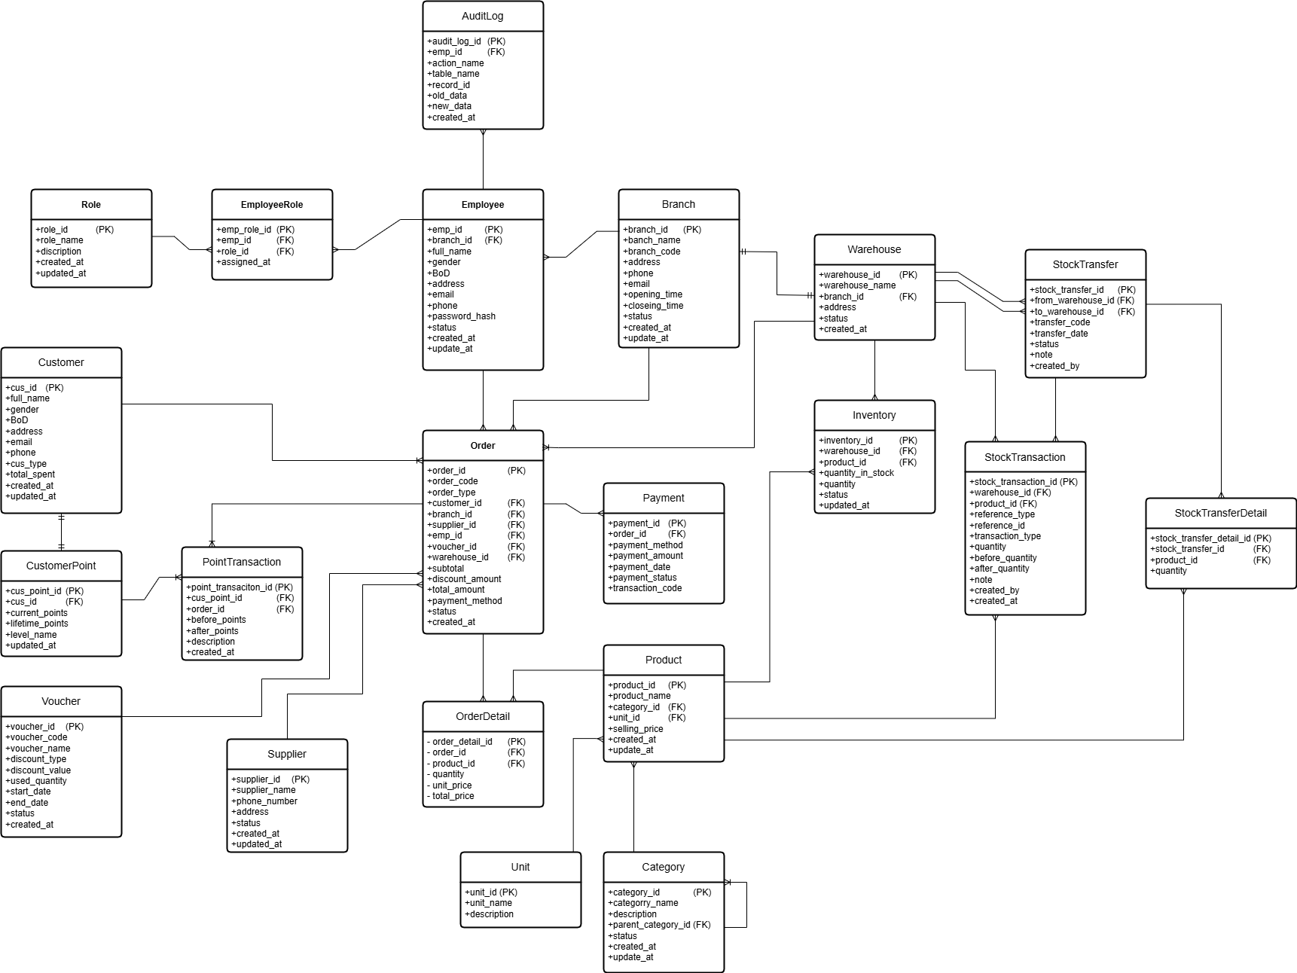

b. Table Descriptions
No | Table | Description
01 | Role | Stores all system roles (e.g., Manager, Cashier, Warehouse Staff, Administrator) that can be assigned to employees through the EmployeeRole table.  Primary Key: role_id
02 | EmployeeRole | Junction table that manages the many-to-many relationship between employees and roles. An employee can have multiple roles, and a role can be assigned to multiple employees.  Primary Key: emp_role_id.  Foreign Keys: emp_id → Employee, role_id → Role
03 | Branch | Stores branch information of the business system. Each branch manages employees, warehouses, customers, and orders.  Primary Key: branch_id
04 | Employee | Stores employee information working at a specific branch. Employees can create orders, stock transactions, stock transfers, and audit records.  Primary Key: emp_id.  Foreign Key: branch_id → Branch
05 | AuditLog | Records important system activities performed by employees, including action type, affected table, modified record, and data changes for auditing purposes. Primary Key: audit_log_id.  Foreign Key: emp_id → Employee
06 | Category | Stores product categories. Supports hierarchical category structures through self-referencing parent categories.  Primary Key: category_id.  Foreign Key: parent_category_id → Category
07 | Unit | Stores product measurement units (e.g., Piece, Box, Bottle, Kilogram). Primary Key: unit_id
08 | Product | Stores product information including name, quantity, category, unit, selling price, and status.  Primary Key: product_id.  Foreign Keys: category_id → Category, unit_id → Unit
09 | Customer | Stores customer information including personal details, contact information, customer type, and accumulated loyalty points.  Primary Key: cus_id
10 | CustomerPoint | Stores the current loyalty point balance and membership level of each customer. Each customer has one corresponding point account.  Primary Key: cus_point_id.  Foreign Key: cus_id → Customer
11 | PointTransaction | Records all loyalty point changes including earning, redemption, adjustment, and expiration transactions.  Primary Key: point_transaction_id.  Foreign Keys: cus_point_id → CustomerPoint, order_id → Order
12 | Supplier | Stores supplier information used for purchasing products and managing procurement activities.  Primary Key: supplier_id
13 | Voucher | Stores discount vouchers that can be applied to customer orders. Includes voucher code, discount value, usage limits, and validity period.  Primary Key: voucher_id
14 | Warehouse | Stores warehouse information belonging to a branch. Warehouses are used to manage product inventories and stock movements.  Primary Key: warehouse_id.  Foreign Key: branch_id → Branch
15 | Inventory | Stores the current stock quantity of each product in a warehouse. Represents the inventory balance by warehouse and product.  Primary Key: inventory_id.  Foreign Keys: warehouse_id → Warehouse, product_id → Product
16 | StockTransaction | Records all inventory movements including stock-in, stock-out, stock adjustment, and stock transfer activities. Tracks quantity before and after each transaction.  Primary Key: stock_transaction_id.  Foreign Keys: warehouse_id → Warehouse, product_id → Product
17 | StockTransfer | Stores stock transfer documents between warehouses. Includes source warehouse, destination warehouse, transfer date, status, and responsible employee.  Primary Key: stock_transfer_id.  Foreign Keys: from_warehouse_id → Warehouse, to_warehouse_id → Warehouse
18 | StockTransferDetail | Stores detailed product information for each stock transfer transaction, including transferred products and quantities.  Primary Key: stock_transfer_detail_id.  Foreign Keys: stock_transfer_id → StockTransfer, product_id → Product
19 | Order | Stores business orders including sales orders and purchase orders. Orders may be associated with customers, suppliers, vouchers, employees, and branches depending on the transaction type.  Primary Key: order_id.  Foreign Keys: customer_id → Customer, branch_id → Branch, supplier_id → Supplier, emp_id → Employee, voucher_id → Voucher, warehouse_id → Warehouse
20 | OrderDetail | Stores detailed product items included in an order, including quantity, unit price, and total price of each line item.  Primary Key: order_detail_id.  Foreign Keys: order_id → Order, product_id → Product
21 | Payment | Stores payment information related to orders, including payment method, amount, status, and transaction reference code.  Primary Key: payment_id.  Foreign Key: order_id → Order

3.2 Code Packages
Package descriptions
No | Package | Description
01 | authentication | Handles user authentication and session management for employees. Supports login, logout, and password recovery/reset features.
02 | authorization | Manages role-based access control (RBAC). Defines permissions for each system role such as admin, manager, cashier, and warehouse staff.
03 | branch_management | Manages branch information including branch creation, updates, address management, phone number, and branch operating status.
04 | employee_management | Manages employee accounts within branches, including role assignment, profile management, account status, password handling, and employee information updates.
05 | audit_log | Records all important actions performed by employees in the system including create, update, delete, and status change operations. Stores old and new data snapshots for traceability.
06 | category_management | Manages product categories and category hierarchy using parent–child relationships. Supports category creation, updates, and status management.
07 | product_management | Manages product information, product name, selling price, cost price, stock alert quantity, status, and category assignment.
08 | provider_management | Manages provider/supplier information including contact details, address, email, phone number, and provider status.
09 | warehouse_management | Manages warehouse information associated with branches including warehouse creation, address management, responsible employee assignment, and warehouse status.
10 | warehouse_transaction | Handles warehouse stock movement operations including stock import, export, adjustment, and inventory updates. Tracks before quantity and after quantity for each transaction.
11 | stock_transfer | Manages stock transfer operations between warehouses. Handles transfer requests, transfer status, source warehouse, destination warehouse, transferred products, and quantity tracking.
12 | customer_management | Manages customer information including personal details, membership tier, loyalty points, and customer contact information.
13 | order_management | Manages order processing for both sales and purchase operations. Handles order creation, order status, subtotal/discount calculations, and customer/provider association.
14 | order_detail_management | Manages product line items inside orders including product quantity, unit price, and subtotal calculations for each order item.
15 | payment_management | Processes payments related to orders. Supports multiple payment methods such as cash, bank transfer, card, and e-wallet. Tracks payment status and payment references.
16 | financial_transaction | Records all branch financial transactions including income, expenses, operational costs, and other financial activities linked to employees and business operations.

II. Requirement Specifications

1. Common Functions

1.1 UC-1.1 Login system

a. Functionalities
UC ID and Name: | UC-1.1 Login system
Created By: | ChiHTH | Date Created: | 22/06/2026
Primary Actor: | Admin, Owner, Store Manager, Sales Staff, Warehouse Staff | Secondary Actors: | None
Trigger: | Users access the system's URL or click the Login button from the homepage.
Description: | Users log into the management system using their phone number/email and password to use authorized features and access relevant branch information.
Preconditions: | The user account has been created, assigned roles, and is not locked.
Postconditions: | - The user has successfully logged into the system.  - The system has correctly identified the role and branch of work.  - The system has recorded the login in the Activity Log.
Normal Flow: | 1.0 System Login Process  1. The user accesses the Login screen.  2. The user enters their phone number/email and password.  3. The user clicks the "Login" button.  4. The system verifies the validity of the login information.  5. The system identifies the user's assigned role and store/branch.  6. The system grants access and directs the user to the corresponding Dashboard screen.  7. The system records the login history in the Activity Log.
Alternative Flows: | 1.1 Forgot Password  1. The user selects the "Forgot Password" link.  2. The system redirects the user to the password recovery flow (UC-1.6 Forgot Password).
Exceptions: | 1.0.E1 Incorrect login information  1. The system displays an error message (Incorrect username or password).  1.0.E2 Account locked  1. The system checks the account status.  2. If the account is locked, the system displays the message "Your account has been locked. Please contact the Admin".
Priority: | P0 (Must-Have)
Frequency of Use: | Regularly (each time an employee starts their shift)
Business Rules: | BR-LOGIN-01, BR-LOGIN-02, BR-LOGIN-03, BR-LOGIN-04, BR-LOGIN-05
Other Information:
Assumptions: | User passwords are stored in encrypted form (BCrypt) in the database.

b. Business Rules
ID | Business Rule | Business Rule Description
BR-LOGIN-01 | Encrypt passwords | User passwords must be encrypted during storage and verification (BCrypt).
BR-LOGIN-02 | Account status | Users cannot log in if their account is in the "Locked" state.
BR-LOGIN-03 | RBAC permissions | The system must determine the role upon login in order to display the permitted functional modules.
BR-LOGIN-04 | Branch identification | All login sessions must be associated with a specific store ID (store_id) to filter the data.
BR-LOGIN-05 | Login limits | If you enter the wrong password more than 6 times in a row, your account will be automatically locked for 30 minutes.

1.2 UC-1.2 Logout system

a. Functionalities
UC ID and Name: | UC-1.2 Logout system
Created By: | ChiHTH | Date Created: | 22/06/2026
Primary Actor: | Admin, Owner, Store Manager, Sales Staff, Warehouse Staff | Secondary Actors: | None
Trigger: | Users click the "Logout" button or link on the navigation bar or account menu.
Description: | Users can securely end their current session to protect their information and allow others to use the device.
Preconditions: | The user is currently logged in to the system.
Postconditions: | - The user's session is completely terminated.  - The system records the logout time in the Activity Log.  - The user is redirected back to the Login screen.
Normal Flow: | 1.2 System Logout Procedure  1. The user clicks the "Logout" button on the interface.  2. The system cancels the current session (invalidate session).  3. The system records the logout event in the Activity Log.  4. The system redirects the user to the Login Screen.
Alternative Flows: | None
Exceptions: | 1.2 E1 Server Connection Error  1. The system is unable to send a session cancellation request to the server.  2. The system displays a connection error message.  3. After reconnection or after a timeout, the system automatically deletes local session information in the browser and requests a login.
Priority: | P0 (Must-Have)
Frequency of Use: | Regularly (at the end of each shift or when leaving the workstation).
Business Rules: | BR-03
Other Information:
Assumptions: | The user's browser allows the deletion of session cookies after logging out.

b. Business Rules
ID | Business Rule | Business Rule Description
BR-LOGOUT-01 | Audit Log | All actions taken by a user to end a work session must be automatically logged by the system for the purpose of verifying work time.
BR-LOGOUT-02 | Cancel access | After logging out, all requests to access authentication pages via direct URLs will be blocked and redirected to the Login page.
BR-LOGOUT-03 | Security at the POS counter | For sales staff, logging out is mandatory at the end of each shift to ensure that revenue from the next shift is not mistakenly recorded in the previous shift's account.
BR-03 | Activity log | All successful or failed password recovery requests must be logged, including a timestamp and the IP address of the requester, for security purposes.

1.3 UC-1.6 Forgot password (chi)

a. Functionalities
UC ID and Name: | UC-1.6 Forgot password
Created By: | ChiHTH | Date Created: | 22/06/2026
Primary Actor: | Admin, Owner, Store Manager, Sales Staff, Warehouse Staff | Secondary Actors: | Mail Provider (Gmail/SMTP)
Trigger: | Users click on the "Forgot password?" link on the Login screen.
Description: | Users regain account access through an email verification process and receive a temporary password automatically generated by the system.
Preconditions: | The user account must exist in the system and be linked to a valid email address.
Postconditions: | - An email containing a temporary password was successfully sent to the user.  - The system recorded the recovery request in the Activity Log.
Normal Flow: | 1.6 Password Recovery Process  1. The user accesses the "Forgot Password" screen.  2. The user enters their username and email address to verify their account.  3. The user clicks the "Reset Password" button.  4. The system checks the existence and status of the account. 5. The system automatically generates a new temporary password (encrypted using MD5/Bcrypt).  6. The system sends a verification email with the new password to the user's email address via a mail provider.  7. The system displays the message "Recovery password successfully sent".  8. The system records the password reset request in the Activity Log.  9. The system redirects the user back to the Login screen.
Alternative Flows: | None
Exceptions: | 1.6.0.E1 Account Information Does Not Exist  1. The system displays the error message: "Email or Username does not exist in the system."  2. The user re-enters the information or cancels the operation.  1.6.0.E2 Mail Service Error  1. The system cannot connect to the Mail Provider.  2. The system displays the error message: "Mail service is currently unavailable. Please try again later."
Priority: | P0 (Must-Have)
Frequency of Use: | Occasionally (when users forget their password).
Business Rules: | BR-02, BR-03, BR-LOGIN-01, BR-LOGIN-02.
Other Information:
Assumptions: | The system has been correctly configured with the Mail Provider's SMTP server to send emails.

b. Business Rules
ID | Business Rule | Business Rule Description
BR-LOGIN-01 | Encrypt passwords | User passwords must be encrypted during storage and verification (BCrypt).
BR-LOGIN-02 | Account status | Users cannot log in if their account is in the "Locked" state.
BR-03 | Activity log | All successful or failed password recovery requests must be logged, including a timestamp and the IP address of the requester, for security purposes.
BR-FORGOT-01 | Request limits | An account is only allowed to request password recovery a maximum of 3 times within 24 hours to prevent spamming.

1.4 UC-1.7 View profile (dũng)

1.5 UC-1.8 Change password(dũng)

1.6 UC-4.1 Search Product (hoàng)

1.7 UC-4.7 Search Customer(dũng)

1.8 UC-1.5 Activity Log (hoàng)

2. Patron Feature

2.1 UC-4.2 Create order (phúc)

a. Functional Description
UC ID and Name: | UC-2_Login System
Created By: | MinhNNT | Date Created: | 16/Jun/2023
Primary Actor: | Customer | Secondary Actors: | None
Trigger: | User clicks Login button from the page header, or  User accesses an authenticated feature (from a link or type the page URL directly into the address bar)
Description: | As a user, I want to be able to log into the system so that I can use the system’s authenticated features and access my personalized account.
Preconditions: | User account has been created & authorized
Postconditions: | · User logs in the system successfully  · The system tracked successful login into the Activity Log
Normal Flow | 2.0 Login System  1. User accesses the User Login screen  2. User types in the login details or choo other login options (see 2.1 and 2.2)  3. User clicks the Login button  4. System validates the login details (see 2.0.E1)  5. System allows user to access  6. System tracks user’s success login to the Activity Log  7. System accesses the Home Page (or the previous calling page if any)
Alternative Flows: | 2.1 Google Login  1. User chooses to login system using Google account  2. System redirects the user to the Google’s Login screen  3. User types in the Google account details and chooses to login  4. Google validates user’s login information successfully and redirect him/her back to the system  5. Return to step 5 of normal flow.  2.2 Facebook Login  1. User chooses to login system using Facebook account  2. System redirects the user to the Facebook’s Login screen  3. User types in the Facebook account details and chooses to login  4. Facebook validates user’s login information successfully and redirect him/her back to the system  5. Return to step 5 of normal flow.
Exceptions: | 2.0.E1 System can’t authenticate the user  1. The Error Message screen is shown to the user  2. User cancels the logging in => UC stops, change to UC-1_View Home Page  3. User clicks “Forgot Password?” link => change to UC-3_Reset Password  4. User clicks “Register” link => change to UC-4_Register User Account
Priority: | Must Have
Frequency of Use:
Business Rules: | FR1, FR2, FR3
Other Information:
Assumptions:

b. Business Rules
ID | Business Rule | Business Rule Description
FR1 | Password Encoding | User’s password must be encoded with MD5 hashing
FR2 | Invalid Logging In | User can’t be authenticated to login the system if below cases  · His/her logging-in details are incorrect  · His/her account has not been verified  · His/her account has been locked or blocked
FR3 | Account Locking | If user inputs wrong logging-in details 6 times continuously, his/her account would be locked in 30 minutes

2.2 UC-4.4 Cash payment (thắng)

a. Functional Description
ID and Name: | UC-5 Order a Meal
Created By: | Prithvi Raj | Date Created: | 10/4/13
Primary Actor: | Patron | Secondary Actors: | Cafeteria Inventory System
Description: | A Patron accesses the Cafeteria Ordering System from the corporate intranet or from home, views the menu for a specific date if desired, selects food items, and places an order for a meal to be delivered to a specified location within a specified 15-minute time window.
Trigger: | A Patron indicates that he wants to order a meal
Preconditions: | PRE-1. Patron is logged into COS.  PRE-2. Patron is registered for meal payments by payroll deduction.
Postconditions: | POST-1. Meal order is stored in COS with a status of “Accepted”.  POST-2. Inventory of available food items is updated to reflect items in this order.  POST-3. Remaining delivery capacity for the requested time window is updated.
Normal Flow: | 5.0 Order a Single Meal  1. Patron asks to view menu for a specific date. (see 5.0.E1, 5.0.E2)  2. COS displays menu of available food items and the daily special.  3. Patron selects one or more food items from menu. (see 5.1)  4. Patron indicates that meal order is complete. (see 5.2)  5. COS displays ordered menu items, individual prices, and total price, including taxes and delivery charge.  6. Patron either confirms meal order (continue normal flow) or requests to modify meal order (return to step 2).  7. COS displays available delivery times for the delivery date.  8. Patron selects a delivery time and specifies the delivery location.  9. Patron specifies payment method.  10. COS confirms acceptance of the order.  11. COS sends Patron an email message confirming order details, price, and delivery instructions.  12. COS stores order, sends food item information to Cafeteria Inventory System, and updates available delivery times.
Alternative Flows: | 5.1 Order multiple identical meals  1. Patron requests a specified number of identical meals. (see 5.1.E1)  2. Return to step 4 of normal flow.  5.2 Order multiple meals  1. Patron asks to order another meal.  2. Return to step 1 of normal flow.
Exceptions: | 5.0.E1 Requested date is today and current time is after today’s order cutoff time  1. COS informs Patron that it’s too late to place an order for today.  2a. If Patron cancels the meal ordering process, then COS terminates use case.  2b. Else if Patron requests another date, then COS restarts use case.  5.0.E2 No delivery times left  1. COS informs Patron that no delivery times are available for the meal date.  2a. If Patron cancels the meal ordering process, then COS terminates use case.  2b. Else if Patron requests to pick the order up at the cafeteria, then continue with normal flow, but skip steps 7 and 8.  5.1.E1 Insufficient inventory to fulfill multiple meal order  1. COS informs Patron of the maximum number of identical meals he can order, based on current available inventory.  2a. If Patron modifies number of meals ordered, then Return to step 4 of normal flow.  2b. Else if Patron cancels the meal ordering process, then COS terminates use case.
Priority: | High
Frequency of Use: | Approximately 300 users, average of one usage per day. Peak usage load for this use case is between 9:00 A.M. and 10:00 A.M. local time.
Business Rules: | BR-1, BR-2, BR-3, BR-4, BR-11, BR-12, BR-33
Other Information: | 1. Patron shall be able to cancel the meal ordering process at any time prior to confirming it.  2. Patron shall be able to view all meals he ordered within the previous six months and repeat one of those meals as the new order, provided that all food items are available on the menu for the requested delivery date. (Priority = M)  3. The default date is the current date if the Patron is using the system before today’s order cutoff time. Otherwise, the default date is the next day that the cafeteria is open.
Assumptions: | Assume that 15 percent of Patrons will order the daily special (source: previous 6 months of cafeteria data).

b. Business Rules
None

2.3 UC-4.5 VNPay payment (thắng)

a. Functional Description
ID and Name: | UC-6 Register for Payroll Deduction
Created By: | Nancy Anderson | Date Created: | 9/15/13
Primary Actor: | Patron | Secondary Actors: | Payroll System
Description: | Cafeteria patrons who use the COS and have meals delivered must be registered for payroll deduction. For noncash purchases made through the COS, the cafeteria will issue a payment request to the Payroll System, which will deduct the meal costs from the next scheduled employee payday direct deposit.
Trigger: | Patron requests to register for payroll deduction, or Patron says yes when COS asks if he wants to register
Preconditions: | PRE-1. Patron is logged into COS.
Postconditions: | POST-2. Patron is registered for payroll deduction.
Normal Flow: | 6.0 Register for Payroll Deduction  1. COS asks Payroll System if Patron is eligible to register for payroll deduction.  2. Payroll System confirms that Patron is eligible to register for payroll deduction.  3. COS asks Patron to confirm his desire to register for payroll deduction.  4. If so, COS asks Payroll System to establish payroll deduction for Patron.  5. Payroll System confirms that payroll deduction is established.  6. COS informs Patron that payroll deduction is established.
Alternative Flows: | None
Exceptions: | 6.0.E1 Patron is not eligible for payroll deduction  6.0.E2 Patron is already enrolled for payroll deduction
Priority: | High
Business Rules: | BR-86 and BR-88 govern an employee’s eligibility to enroll for payroll deduction.
Other Information: | Expect high frequency of executing this use case within first 2 weeks after system is released.

b. Business Rules
None

2.4 UC-4.3 Discount applies (Thắng)

2.5 UC-4.9 Earn customer points (Dũng)

2.6 UC-4.10 Redeem consumption points (Dũng)

2.7 UC-5.3 Receiving goods into the warehouse (Receiving goods) (tháng)

2.8 UC-5.7 Warehouse transfer (thắng)

2.9 UC-5.6 Check inventory (thắng)

2.10 UC-3.11 Import receipt (hoàng sửa cả cái này tạo phiếu thu)

2.11 UC-3.12 Create payment voucher (hoàng sửa cái tạo phiếu chi này nhé, sửa cả name usecase)

2.12 UC-3.14 Check the store's cash register (chi)

III. Design Specifications

1. <<Feature Name>>

1.1 <<SubFeature Name>>

a. <<Screen/Function Name>>
[Provide brief description of the screen/function + related UC here and other details as in the sub-sections]

UI Design
[This is to describe the UI layout (Mockup prototype) & descriptions for screen fields/components]
<<Mockup prototype>>
Field Name | Field Type | Description
Field Group Name
<<Field-Name>> | <<Field type>> | <<Field description & data initializing design>>

Database Access
[Provide the design description for the screen/function to access the database here: what table the screen/function would access, which transactions does it make (C-Create, R-Read, U-Update, or D-Delete), and how/purpose of the access (by providing Description and SQL commands)]
Table | CRUD | Description
<<Table Name>> | <<transaction(s)>> | <<Table access description: purpose, how,…>>
..

SQL Commands
[Provide the detailed SQL (select, insert, update...) which are used in implementing the screen/function]

1.2 System Access

a. User Login
This screen allows user to be authenticated to the system screens/functionalities.
Related use cases:
· UC02_Login System

UI Design

Field Name | Field Type | Description
Email* | Text Box | This is for user to input valid email address for logging in
Password* | Password Box | This is for user to input password for logging in
Login | Button | User clicks to authenticate him/herself into the system with provided email & password
Register | Button | User clicks to redirect to the User Register page for registering new user account to access the system
Forgot Password? | Hyperlink | User clicks to redirect to the Password Reset page for resetting his/her forgot password
Login with Google | Hyperlink | Allow user to login with his/her Google account
Login with Facebook | Hyperlink | Allow user to login with his/her Facebook account

Database Access
Table | CRUD | Description
User | R | Verify UserName & Password information
Setting, User | R | Specify the authorizations of the logged-in user

SQL Commands:
1/ Verify UserName & Password information
SELECT user_id, full_name, email, image_url, status
FROM user WHERE user_name = ? AND password = ?

2/ Specify the authorizations of the logged-in user
SELECT mapped_values FROM setting WHERE setting_id = ?
SELECT setting_name, mapped_values FROM setting WHERE setting_id IN (?)

b. Setting List

UI Design

Field Name | Field Type | Description
Search Fields
Setting Type | Combo Box  Single-Choice | Filled with the list of current active setting types  Allow to filter the list by setting type;  Default value is “All Types”
Setting Status | Combo Box  Single-Choice | Values: All Statuses (default), Active, and Inactive  Allow to filter the list by status  Default value: “All Statuses”
Search Phase | Text Box  String (30) | Allow to search using the name or map values  Default value: blank
Search | Button | Click to refresh the list with the defined filter(s) and search phrase.
Add New | Hyperlink | Click to open the Setting Details page for adding new setting (master data)
Data Table
ID | Integer | Auto-increased identifier of the setting
Name | Text | Name of the setting
Mapped Values | Text | Supplementary information for the setting
Type | Text | Type of the setting
Order | Integer | Display order of the setting: the order of the setting type, displayed among the list of settings with the same type
Data Actions
Edit | icon | Click to open the Setting Details page for updating the relevant setting (master data)
Activate | icon | Shown when the data status is inactive. This is to activate the relevant setting (master data)
Deactivate | Ion | Shown when the data status is active. This is to deactivate the relevant setting (master data)

Database Access
Table | CRUD | Description
Setting | RU | Query the list of current settings from the database  Update status of a specific setting

SQL Commands:
1/ Query the list of current settings from the database
SELECT setting_id, setting_name, mapped_values, type_id, display_order, status
FROM setting WHERE (setting_type = ?) AND (status = ?) AND (setting_name LIKE ?)

2/ Update status of a specific setting
UPDATE setting SET status = ? WHERE setting_id = ?

c. Setting Details

UI Design

Field Name | Field Type | Description
Name* | Text Box  String (20) | Name of the setting
Type* | Combo Box  (Single Choice) | Type of the setting, filled with the list of setting types  Default value: the first type in the list
Mapped Values | Text Box  String (50) | Supplementary information for the setting (if any)
Order | Text Box  Integer (>=0) | Display order of the setting: the order of the setting type, displayed among the list of settings with the same type
Status | On/Off button | Status of the setting: Active or Inactive  Default value: Active
Description | Text Area  String (200) | Description of the setting
Submit | Button | Click to store new or updated setting details
Reset | Button | Click to reset the changes use has made on the screen fields back to the initial values when the screen is loaded

Database Access
…

IV. Appendix
1.
2.
3.

1. Assumptions & Dependencies
[Record any assumptions that were made when conceiving the project and writing this vision and scope document. Note any major dependencies the project must rely upon for success, such as specific technologies, third-party vendors, development partners, or other business relationships.]
<<Sample:
AS-1: Systems with appropriate user interfaces will be available for cafeteria employees to process the expected volume of meals ordered.
AS-2: Cafeteria staff and vehicles will be available to deliver all meals for specified delivery time slots within 15 minutes of the requested delivery time.
DE-1: If a restaurant has its own on-line ordering system, the Cafeteria Ordering System must be able to communicate with it bi-directionally.
>>

2. Limitations & Exclusions
[Identify any product features or characteristics that a stakeholder might anticipate, but which are not planned to be included in the new product]

3. Business Rules
[Provide common business rules that you must follow. The information can be provided in the table format as the sample below]
<<Sample
ID | Category | Rule Definition
BR-01 | Constraints | Delivery time windows are 15 minutes, beginning on each quarter hour.
BR-02 | Constraints | Deliveries must be completed between 10:00 A.M. and 2:00 P.M. local time, inclusive.
BR-03 | Facts | All meals in a single order must be delivered to the same location.
BR-04 | Facts | All meals in a single order must be paid for by using the same payment method.
BR-11 | Constraints | If an order is to be delivered, the patron must pay by payroll deduction.
BR-12 | Computations | Order price is calculated as the sum of each food item price times the quantity of that food item ordered, plus applicable sales tax, plus a delivery charge if a meal is delivered outside the free delivery zone.
>>

4. ..

